Character Recognition Neural Network
Implementation Report
A From-Scratch NumPy Implementation for 35-Class Character Classification
Prepared by: Dhivakar B
210425148024
AI/ML Internship Assignment
September 2026

1. Objective
The objective of this project is to implement a neural network entirely from scratch, using only NumPy, to classify 35 character classes: uppercase letters A-Z and digits 1-9. No deep learning framework (TensorFlow, PyTorch, or Keras) is used at any stage. The implementation covers the complete pipeline required for a working classifier: dataset preparation, forward propagation, backpropagation, activation functions (ReLU and Softmax), cross-entropy loss, mini-batch gradient descent, a validation loop, and post-training evaluation including a confusion matrix and error analysis.
The guiding principle throughout was to verify every component against small, hand-computable numeric examples before trusting it on the real dataset and full-size network, rather than assuming correctness from the formulas alone.

2. Methodology

2.1 Dataset Generation
No external dataset was used. MNIST covers only digits 0-9, and EMNIST-letters covers only 26 letters -- neither matches this project's exact 35-class set (A-Z plus 1-9) without artificially stitching together mismatched sources. Instead, a synthetic dataset was generated programmatically, giving full control over class balance and complete reproducibility.
The dataset generation pipeline consisted of the following steps:
- Font discovery: scanned all fonts available on the system (191 font files, 79 unique families) using matplotlib.font_manager.
- Font filtering: excluded symbol fonts (e.g. Wingdings), non-Latin scripts, mathematical/STIX fonts, and fonts that rendered incorrectly or illegibly on visual inspection, leaving 30 clean, verified fonts.
- Rendering: each character was rendered centered on a 64x64 white canvas using PIL, with the font chosen at random per sample from the 30-font pool.
- Augmentation: random rotation (-12 to +12 degrees), random translation (-4 to +4 pixels), and Gaussian pixel noise (standard deviation 8) were applied to each rendered character to simulate natural variation.
- Preprocessing: images were resized to 28x28 using LANCZOS resampling, normalized to the [0, 1] range, and flattened into 784-length feature vectors.
A total of 14,000 images were generated (35 classes x 400 samples per class). The dataset was split into training, validation, and test sets using a stratified split, which preserves the per-class proportions exactly across all three sets.
Split | Samples | Shape
Train | 9,800 | (9800, 784)
Validation | 2,100 | (2100, 784)
Test | 2,100 | (2100, 784)

Each class contributed exactly 280 training, 60 validation, and 60 test samples, confirming the stratified split preserved class balance exactly rather than only matching aggregate totals.

2.2 Network Architecture
The network uses a single hidden layer: 784 -> 128 -> 35. The input size (784) is fixed by the 28x28 image dimensions, and the output size (35) is fixed by the number of classes. The hidden layer size (128) is a chosen hyperparameter, not derived from the problem -- it was selected as a standard, well-established starting point for a shallow MLP on clean, non-photographic image data, balancing representational capacity against the complexity of the hand-derived backpropagation math.
Layer | Size | Activation | Initialization
Input | 784 | - | -
Hidden | 128 | ReLU | He: sqrt(2/n_in)
Output | 35 | Softmax | Xavier: sqrt(1/n_in)

Weights were initialized randomly (not to zero or any constant) to break symmetry between neurons -- if every neuron in a layer started with identical weights, they would receive identical gradients during backpropagation and update identically forever, effectively collapsing the layer's capacity to that of a single neuron. He initialization was used for the ReLU-activated hidden layer, and Xavier initialization for the Softmax-activated output layer, both scaling the weight variance according to the number of inputs to each layer so that the pre-activation values remain in a reasonable numeric range regardless of layer width. Biases were initialized to zero, which is safe since each bias affects only its own neuron and does not cause the same symmetry problem as shared weight values.

2.3 Implementation Details
The following components were implemented from scratch in NumPy and verified against hand-computed examples before being used on real data:
- Forward propagation: Z1 = W1.X + b1, A1 = ReLU(Z1), Z2 = W2.A1 + b2, A2 = Softmax(Z2).
- Softmax: computed with a max-subtraction step for numerical stability, which does not change the mathematical result (it cancels out in the normalization) but prevents overflow from large raw scores.
- Cross-entropy loss: for each sample, -log(probability assigned to the true class), averaged across the batch. Loss is low when the network is confidently correct and grows sharply as confidence in the correct class approaches zero.
- Backpropagation: dZ2 = A2 - Y (the standard Softmax + cross-entropy combined derivative), followed by dW2, db2, then propagated backward through dA1 = W2^T . dZ2 and dZ1 = dA1 * ReLU'(Z1), followed by dW1, db1.
- Gradient descent: params -= learning_rate * gradient, applied to all four parameter matrices each update.
Backpropagation was verified on a small 3-input, 2-hidden-neuron, 2-output toy network, with every intermediate value (dZ2, dW2, db2, dA1, dW1, db1) computed by hand and confirmed to match the code's output before scaling up to the real 784-128-35 network.

2.4 Worked Example: Verifying Backpropagation by Hand
To confirm the implementation was mathematically correct before running it on real data, a small toy network (3 inputs, 2 hidden neurons, 2 output classes) was worked through step by step, both by hand and in code, and the two were compared.
Inputs and initial parameters:
- x = [1, 2, 3]
- W1 = [[0.1, 0.0, 0.2], [0.3, 0.1, 0.0]], b1 = [0.1, 0.0]
- W2 = [[0.5, -0.2], [-0.1, 0.4]], b2 = [0.0, 0.0]
- True class: output neuron 0 (one-hot Y = [1, 0])
Step 1 -- Forward propagation:
- Z1 = W1.x + b1 = [0.1(1)+0.0(2)+0.2(3)+0.1, 0.3(1)+0.1(2)+0.0(3)+0.0] = [0.8, 0.5]
- A1 = ReLU(Z1) = [0.8, 0.5] (both already positive, unchanged)
- Z2 = W2.A1 + b2 = [0.5(0.8)+(-0.2)(0.5), -0.1(0.8)+0.4(0.5)] = [0.3, 0.12]
- A2 = Softmax(Z2) = [0.545, 0.455] (sums to 1.0)
Step 2 -- Loss:
- Cross-entropy loss = -log(0.545) = 0.607 (probability assigned to the correct class, neuron 0)
Step 3 -- Backward propagation:
- dZ2 = A2 - Y = [0.545 - 1, 0.455 - 0] = [-0.455, 0.455]
- dW2 = dZ2 (outer product) A1 = [[-0.364, -0.228], [0.364, 0.228]]
- db2 = dZ2 = [-0.455, 0.455]
- dA1 = W2^T . dZ2 = [0.5(-0.455)+(-0.1)(0.455), -0.2(-0.455)+0.4(0.455)] = [-0.273, 0.273]
- dZ1 = dA1 * ReLU'(Z1) = [-0.273, 0.273] (both Z1 values were positive, so ReLU'(Z1) = [1, 1] and dZ1 = dA1 unchanged)
- dW1 = dZ1 (outer product) x = [[-0.273, -0.546, -0.819], [0.273, 0.546, 0.819]]
- db1 = dZ1 = [-0.273, 0.273]
Running the same inputs through the actual forward_propagation and backward_propagation functions produced dZ2 = [-0.4551, 0.4551], dW2 = [[-0.3641, -0.2276], [0.3641, 0.2276]], dA1 = [-0.2731, 0.2731], dW1 = [[-0.2731, -0.5461, -0.8192], [0.2731, 0.5461, 0.8192]], and db1 = [-0.2731, 0.2731] -- matching the hand-computed values above (small differences are only rounding from working to three decimal places by hand). This confirmed the implementation was correct before it was trusted on the full 784-128-35 network and the real 14,000-image dataset.

3. Training Process
The network was trained using mini-batch gradient descent: the training set is reshuffled every epoch and split into batches, with one forward -> loss -> backward -> update cycle performed per batch. Validation loss and accuracy were computed after every epoch to monitor generalization.

3.1 Initial Attempt: Dead ReLU Collapse
The first training run used a learning rate of 0.5. Training failed completely: validation accuracy remained frozen at exactly 1/35 (approximately 2.9%, the random-guess baseline) for all 30 epochs, with loss similarly frozen near -log(1/35).
This was diagnosed by directly checking the fraction of hidden neurons producing zero output across a batch of inputs, which showed 100% of hidden neurons permanently inactive. The root cause: the large learning rate pushed every hidden neuron's pre-activation value negative on the very first update. Once a neuron's pre-activation is negative, its ReLU output is zero, and its gradient (via the ReLU derivative) is also zero -- meaning that neuron can never receive an update again. With every hidden neuron dead simultaneously, the entire hidden layer became permanently frozen, and only the output bias continued to shift slightly, settling toward a uniform prediction across all classes.

3.2 Hyperparameter Tuning
Reducing the learning rate to 0.05 resolved the dead-neuron collapse, but introduced a new issue: validation accuracy oscillated sharply between roughly 30% and 75% from epoch to epoch, even though training loss decreased smoothly throughout.
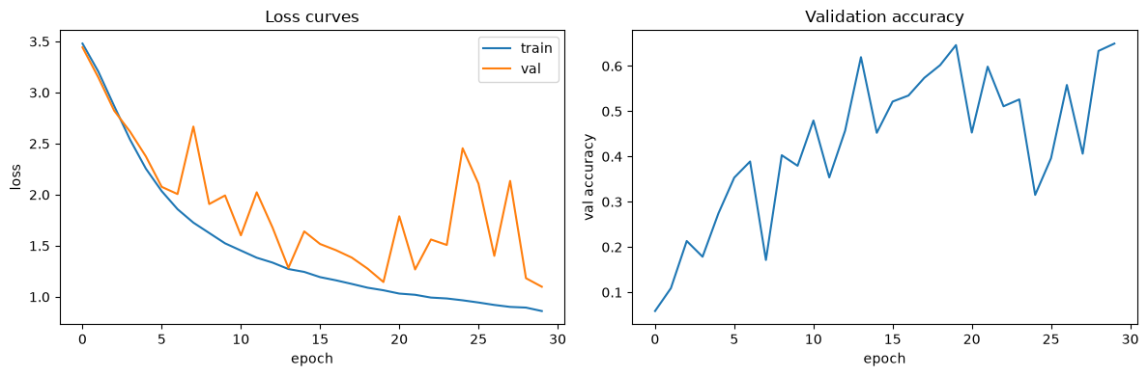
Figure 1: Training loss decreasing smoothly while validation loss and accuracy oscillate sharply (batch_size=64, learning_rate=0.02, 30 epochs).
This pattern -- a smooth training curve alongside a noisy validation curve -- indicated that individual mini-batch gradient estimates were too noisy, causing each update to occasionally overshoot a good solution. Increasing the batch size from 64 to 128 (averaging gradients over more samples per update, giving a steadier estimate of the true gradient direction) resolved the instability.
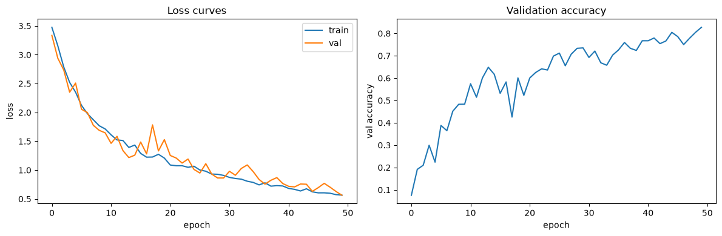
Figure 2: Training and validation loss converging closely after increasing batch_size to 128 (50-epoch checkpoint shown; training was subsequently extended to 80 epochs using this same configuration).

3.3 Final Training Configuration
The final training run used the following configuration:
- Architecture: [784, 128, 35]
- Epochs: 80
- Batch size: 128
- Learning rate: 0.05
- Random seed: 1
Validation accuracy climbed smoothly across the 80 epochs and plateaued near the end, indicating the network had converged for this configuration. The parameters from the best-performing epoch by validation accuracy (epoch 78, 84.95%) were retained as the final model, rather than simply using whichever epoch happened to be last.

4. Results
Metric | Score
Best validation accuracy | 84.95% (epoch 78 of 80)
Final test accuracy | 84.9%

Test accuracy was evaluated on 2,100 held-out images that were not used during training or in any epoch-by-epoch validation check. The close agreement between validation accuracy (84.95%) and test accuracy (84.9%) indicates the network generalizes to unseen data rather than overfitting to the training set.

4.1 Confusion Matrix
A full 35x35 confusion matrix was computed on the test set. The matrix shows a strong diagonal (correct predictions), confirming the overall accuracy, along with a small number of specific, concentrated off-diagonal cells rather than random scattered noise -- indicating that the network's errors follow understandable patterns rather than being arbitrary.
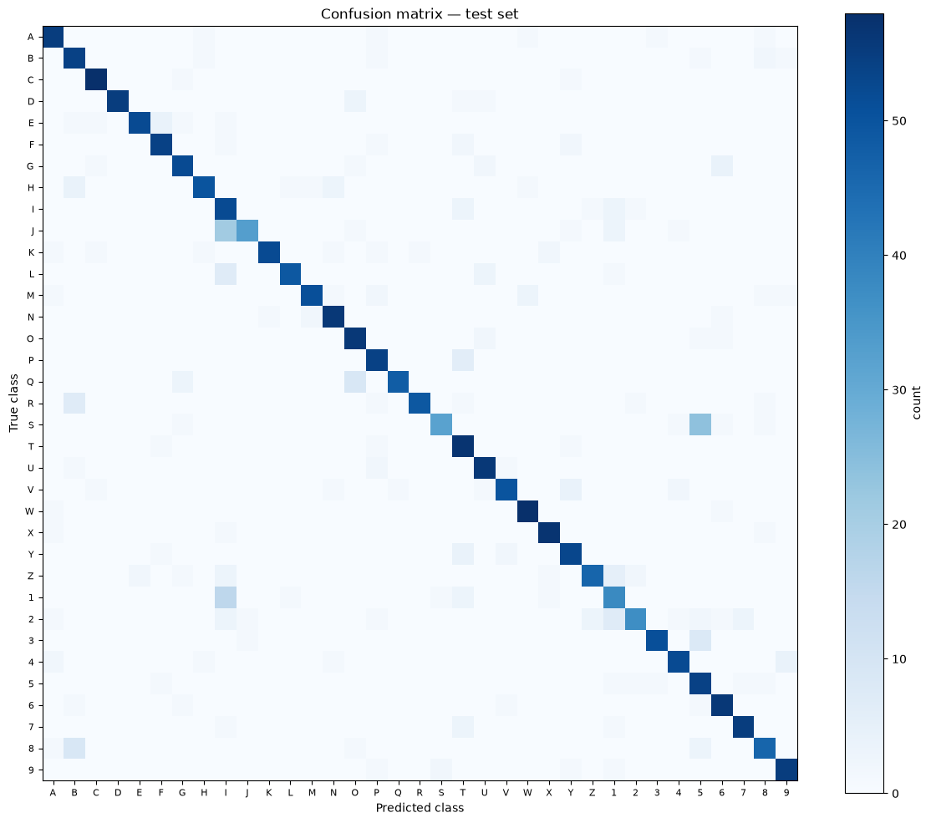
Figure 3: Confusion matrix on the test set (2,100 samples, 35 classes).

5. Error Analysis
Five misclassified test examples were selected directly from the confusion matrix's most prominent off-diagonal cells and inspected individually.
True Class | Predicted Class | Likely Reason
J | I | J's only distinguishing feature is a small bottom hook, which is faint in this rendering and easily lost to augmentation noise.
1 | I | In this font, both characters render as a near-identical simple vertical stroke.
S | 5 | Both characters share a similar curve structure, bending the same direction at the top and bottom.
8 | B | Both are two vertically stacked closed loops; the subtler flat-spine-versus-symmetric-loop distinction is under-weighted by the model.
R | B | A decorative font's flourished leg on R creates an accidental second loop, resembling B's structure.

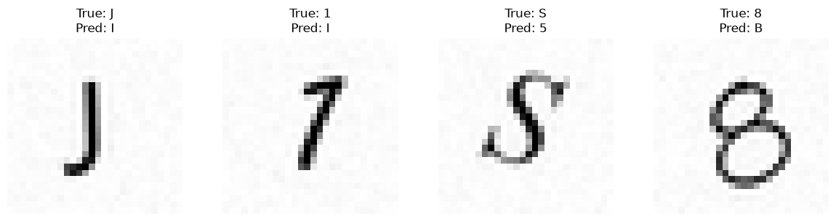
Figure 4: Four misclassified test examples with true and predicted labels (J to I, 1 to I, S to 5, 8 to B).
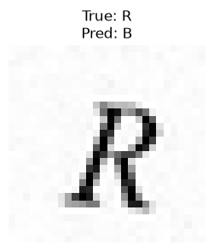
Figure 5: Fifth misclassified example (R predicted as B), from a decorative font.
All five errors are visually reasonable to a human observer as well, given the specific font renderings involved. This suggests the misclassifications stem from genuine visual ambiguity present in certain font styles within the synthetic dataset, rather than from a fundamental flaw in the network's learned representations.

6. Conclusion
This project implemented a complete neural network pipeline from scratch using only NumPy, achieving 84.9% test accuracy on a 35-class character recognition task. Every mathematical component -- forward propagation, backpropagation, activation functions, loss computation, and gradient descent -- was verified against hand-computed examples before being trusted on the real dataset, and a real training failure (the dead ReLU collapse) was diagnosed and resolved rather than avoided by trial and error alone.
Potential directions for future improvement include:
- Training for more epochs, since validation accuracy was still trending upward at epoch 80 and had not fully plateaued.
- Adding a second hidden layer or increasing hidden layer width, particularly to address the specific confusable pairs identified in the error analysis (e.g. I/J, S/5, 8/B/R).
- A systematic hyperparameter search over learning rate and batch size, rather than the manual tuning process documented in Section 3.
- Expanding the augmentation strategy or font set to reduce the specific font-driven ambiguities identified in the error analysis.

